Ideation Phase
Define the Problem Statements

Date | 31 January 2026
Team ID | LTVIP2026TMIDS62122
Project Name | Startup Success Prediction System Using Machine Learning
Maximum Marks | 2 Marks

Customer Problem Statement Template:
Entrepreneurs and investors struggle to make informed decisions about startup success due to the lack of accessible, data-driven prediction tools. The complexity of analyzing funding patterns, industry trends, and performance metrics creates uncertainty and increases financial risk. There is a need for an intelligent system that predicts startup success probability and provides clear analytical insights to support better decision-making.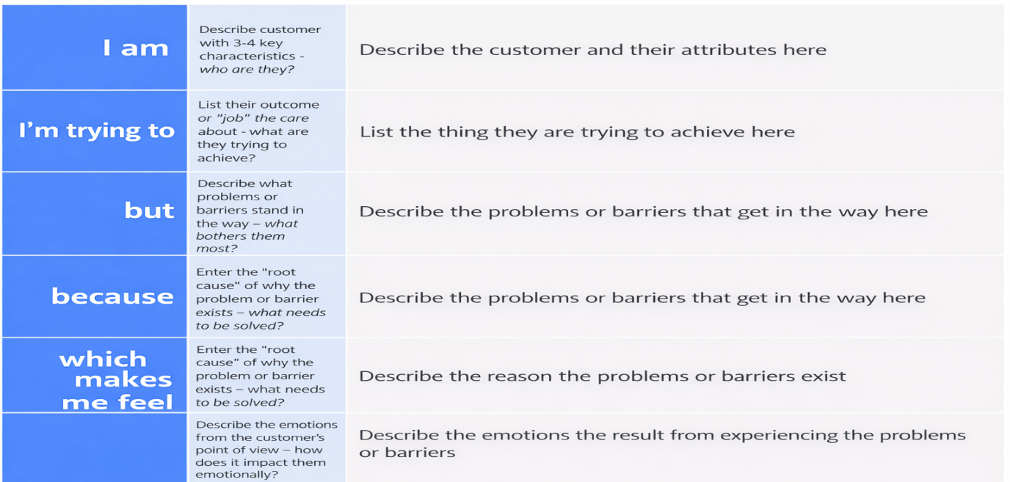
Example:


Problem Statement (PS) | I am (Customer) | I’m trying to | But | Because | Which makes me feel
PS-1 | A startup founder | Predict whether my startup will succeed | I don’t know which factors influence success | There is no simple AI-based prediction tool available | Confused and uncertain
PS-2 | An investor | Identify high-potential startups before investing | It is difficult to manually analyze large amounts of startup data | Data is scattered and requires technical knowledge to interpret | Overwhelmed and doubtful

